WRITTLE PARISH COUNCIL

INVITES ALL RESIDENTS OF WRITTLE PARISH TO THE
ANNUAL PARISH MEETING

MONDAY 9 MARCH 2026 AT 8:00PM
WRITTLE VILLAGE HALL ON THE GREEN

- Meet your Parish Council – ask questions and share concerns
- Essex Police will be talking about their work in the local community
- Find out the latest from ARU
- Did you know that Writtle had a parkrun?
- Refreshments will be available
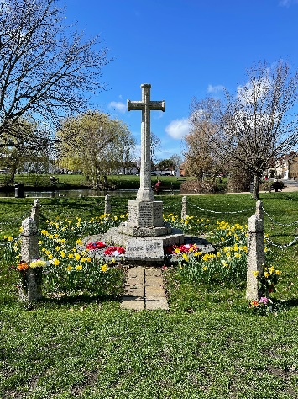
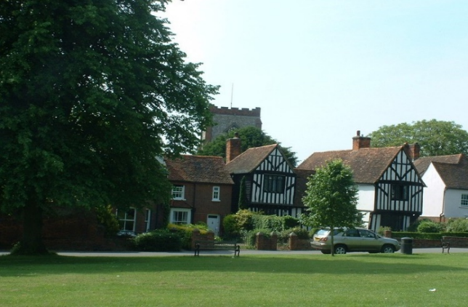
- And much more ….

Writtle Parish Council, Parish Office, The Green, Writtle, Chelmsford, Essex, CM1 3DT.
Tel: 01245 420066

